Reading Spine
We have introduced a store of classic books into each year group called a ‘Reading Spine’. Each year group will read these books, adding other favourites, so that the children become familiar with these core books. Each week the teacher will read some books from the reading spine, other story books, a traditional tale and a non-fiction book. Teachers will also read poems and nursery rhymes every day. Each year group will also read the Reading Spine books of the previous years if applicable.
Great books build the imagination. The more we read aloud expressively, the more memorable the characters, places and events become, building an inner world. Each great book develops the imagination and equips the reader with language. Around 75% of our vocabulary comes from our reading.
“A child who is read to will have an inner kingdom of unicorns, talking spiders and a knife that cuts into other words.” (Pie Corbett)
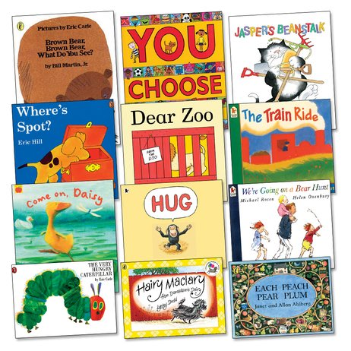

Nursery Reading Spine

